# Measurable and Progress from maladaptive behaviors.

|  |  |  |  |  |  |
| --- | --- | --- | --- | --- | --- |
| Maladaptive Behaviors | Baseline Date:2017-08-28to2017-08-30 | Current average per week (3/31/2020) | % of Reduction(BL-average/ BL)*100 | Status | Updated STO (3/31/2020) |
| Disruption | 21 incidents per weeks | 8 incidents per week. | 60% | In progress | Sto1(MASTERED 2018-03-17). Currently: STO 2(Initiated 4/1/2018) |
| Tantrum | 28 incidents per weeks | 9 incidents per week. | 68% | In progress | Sto1(MASTERED 2018-03-10). Sto2(MASTERED 2018-06-23). Sto3(MASTERED 2020-03-07). Currently: STO 4(Initiated 4/1/2020) |
| Isolation | 42 incidents per weeks | 11 incidents per week. | 74% | In progress | Sto1(MASTERED 2018-02-24). Sto2(MASTERED 2018-05-19). Sto3(MASTERED 2018-12-08). Sto4(MASTERED 2019-04-18). Sto5(MASTERED 2020-01-04). Currently: STO 6(Initiated 2/1/2020) |
| Property Destruction | 21 incidents per weeks | 11 incidents per week. | 50% | In progress | Sto1(MASTERED 2018-03-10). Sto2(MASTERED 2020-03-07). Currently: STO 3(Initiated 4/1/2020) |
| Task Refusal | 21 incidents per weeks | 10 incidents per week. | 52% | In progress | Sto1(MASTERED 2018-03-17). Sto2(MASTERED 2020-01-25). Currently: STO 3(Initiated 2/1/2020) |
| Withdrawal of attention | 35 incidents per weeks | 21 incidents per week. | 40% | In progress | Sto1(MASTERED 2019-05-11). Sto2(MASTERED 2019-07-31). Currently: STO 3(Initiated 8/1/2019) |
| Lying behavior | 28 incidents per weeks | 19 incidents per week. | 33% | In progress | Sto1(MASTERED 2019-07-06). Currently: STO 2(Initiated 8/1/2019) |
| Total of Reduction (%) | - | - | - | - | 54.3112244898 |

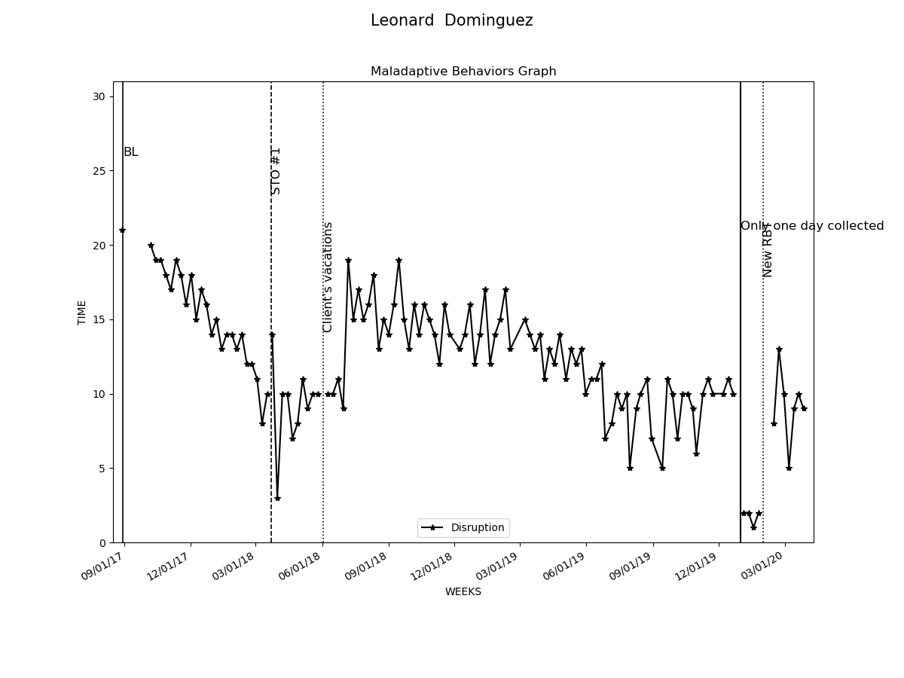

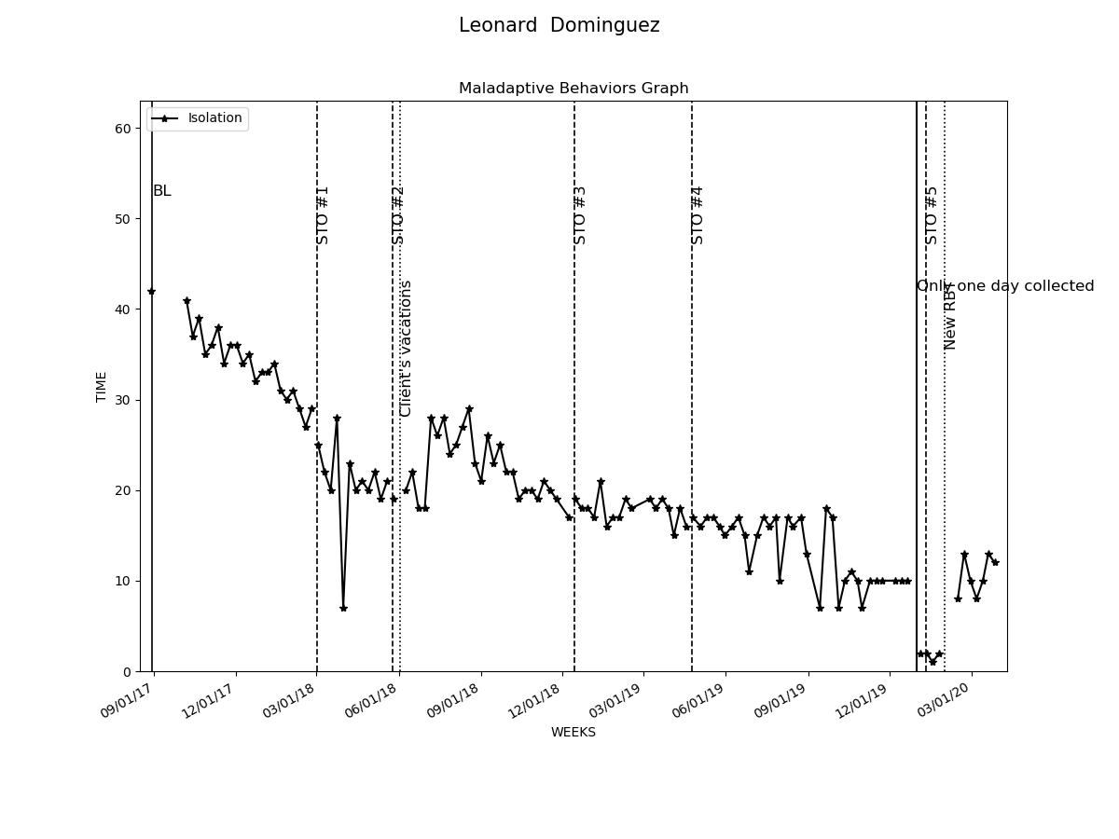

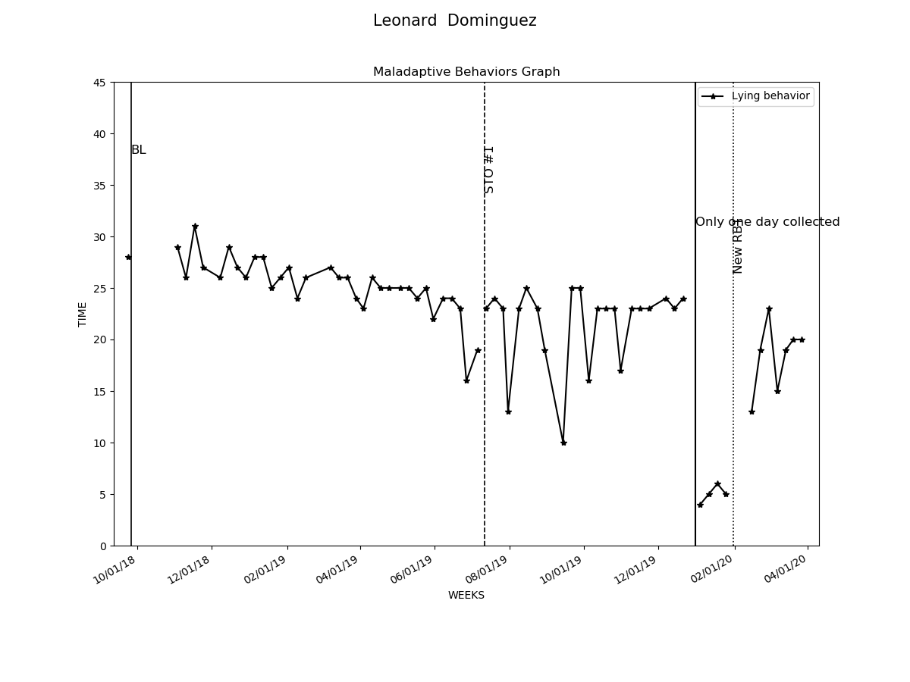

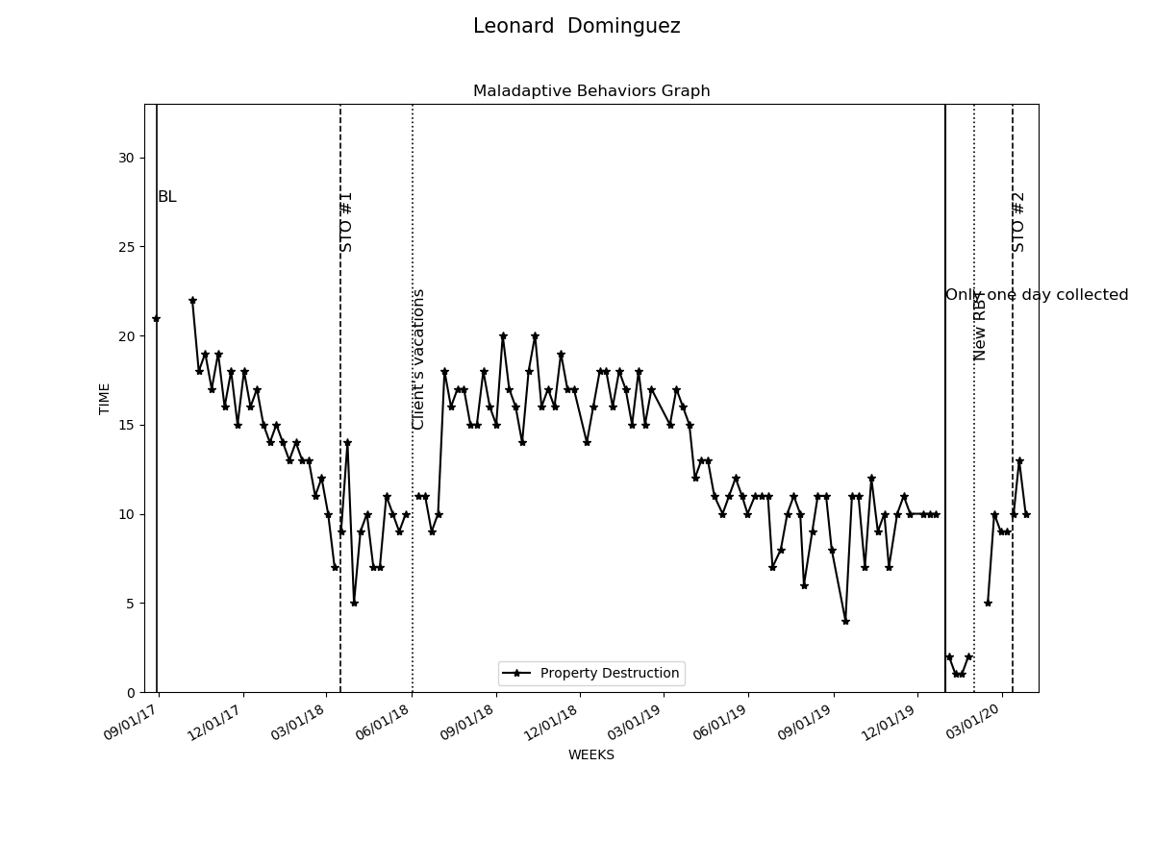

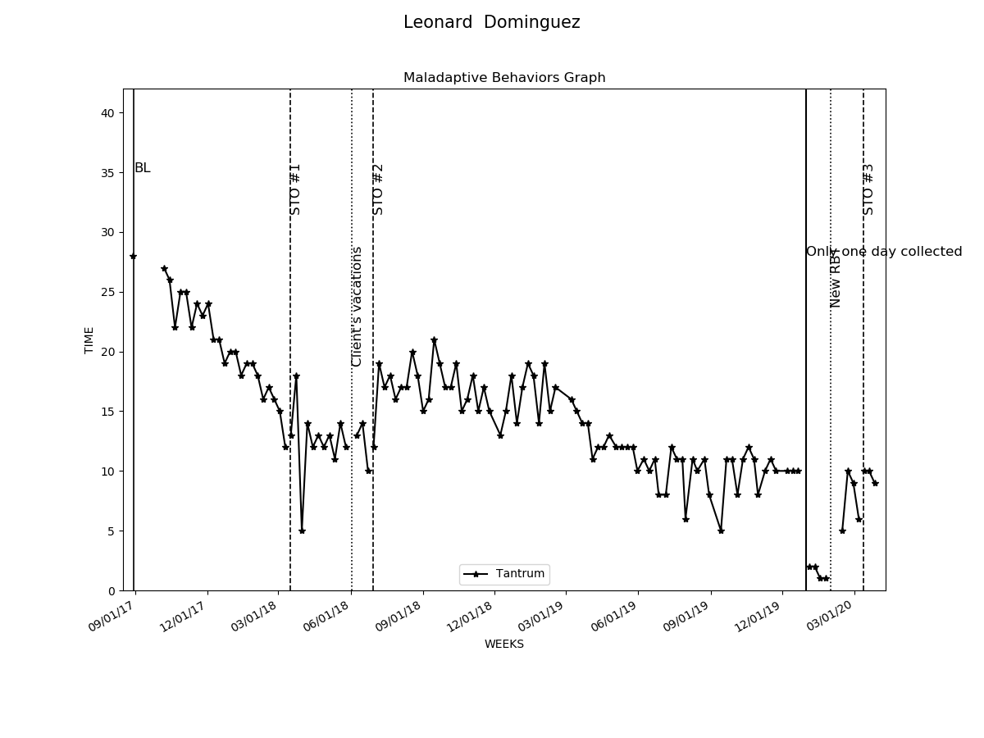

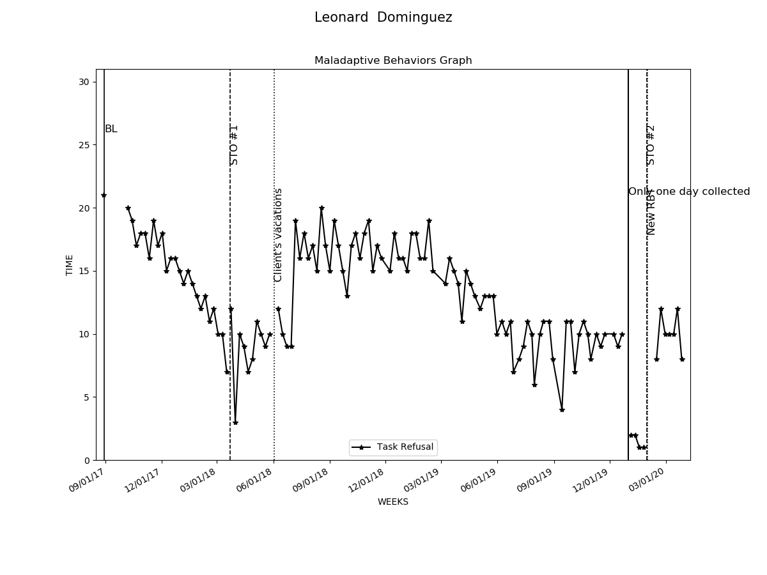

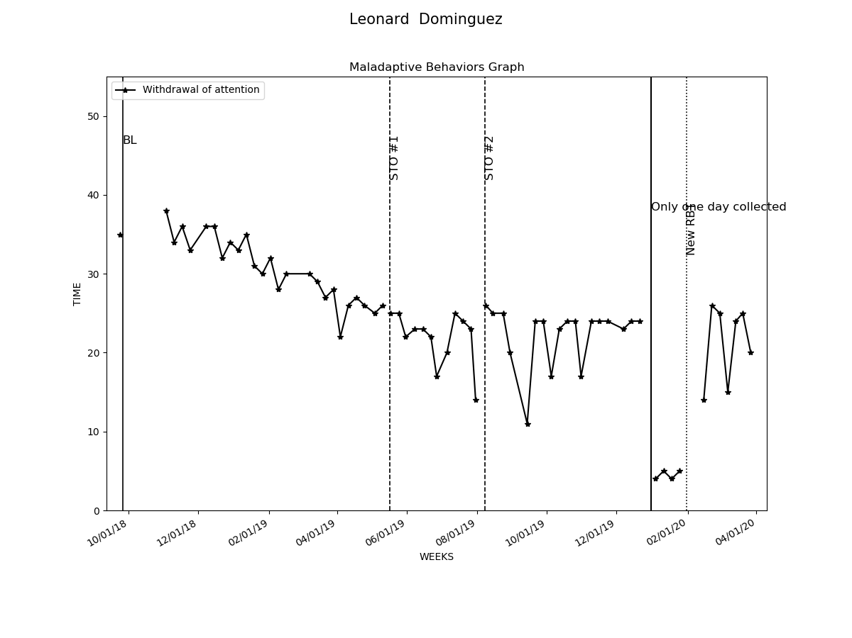

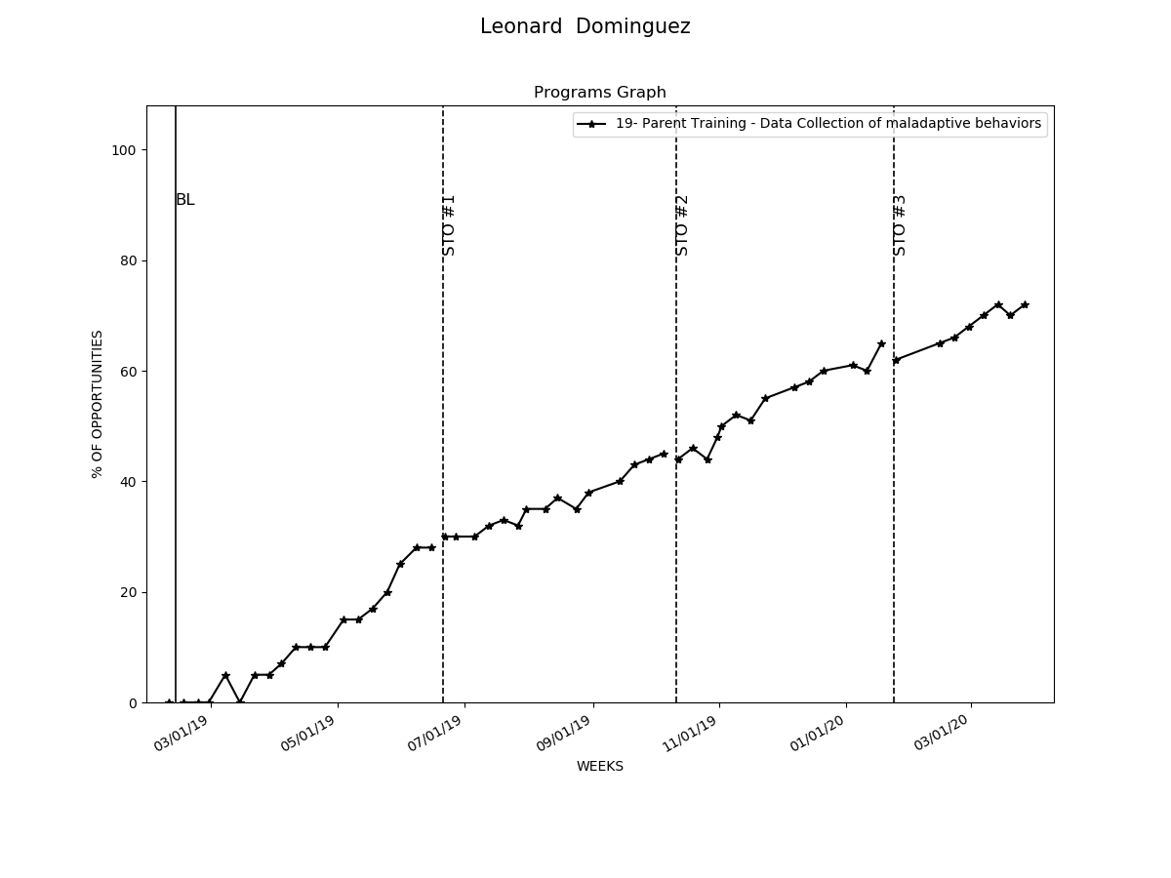

# Graphs Replacement and Interventions

|  |  |  |  |  |
| --- | --- | --- | --- | --- |
| Replacements and Programs | Baseline Date:2017-10-07to2017-10-10 | Current average per week (3/31/2020) | Status | Updated STO (3/31/2020) |
| 1- Request Break | 11% | 81% | LTO in progress | Sto1(MASTERED 2018-02-17). Sto2(MASTERED 2018-06-16). Sto3(MASTERED 2018-09-22). Sto4(MASTERED 2019-05-11). |
| 2- Request Attention | 10% | 84% | LTO in progress | Sto1(MASTERED 2018-02-03). Sto2(MASTERED 2018-06-09). Sto3(MASTERED 2018-09-22). Sto4(MASTERED 2019-05-18). |
| 3- Request Tangible | 11% | 83% | LTO in progress | Sto1(MASTERED 2018-02-10). Sto2(MASTERED 2018-05-19). Sto3(MASTERED 2018-08-25). Sto4(MASTERED 2019-05-11). |
| 4- Follow instructions | 13% | 85% | LTO in progress | Sto1(MASTERED 2018-01-20). Sto2(MASTERED 2018-05-19). Sto3(MASTERED 2018-08-25). Sto4(MASTERED 2019-05-11). |
| 5- Wait for Tangible | 13% | 85% | LTO in progress | Sto1(MASTERED 2018-02-03). Sto2(MASTERED 2018-05-26). Sto3(MASTERED 2018-08-25). Sto4(MASTERED 2019-05-31). |
| 6- Social Skills- Initiate and sustain interaction | 11% | 85% | LTO in progress | Sto1(MASTERED 2018-01-13). Sto2(MASTERED 2018-04-21). Sto3(MASTERED 2018-06-23). Sto4(MASTERED 2019-03-15). |
| 7- Social Skills- Ask for information to peers and adults | 10% | 82% | LTO in progress | Sto1(MASTERED 2018-02-03). Sto2(MASTERED 2018-05-19). Sto3(MASTERED 2018-08-25). Sto4(MASTERED 2019-05-31). |
| 8- Social Skills- Interrupt conversation politely | 10% | 85% | LTO in progress | Sto1(MASTERED 2018-03-10). Sto2(MASTERED 2018-07-14). Sto3(MASTERED 2018-10-13). Sto4(MASTERED 2019-05-11). |
| 9- Social Skills- Converse with others in appropriate manner | 13% | 86% | LTO in progress | Sto1(MASTERED 2017-12-23). Sto2(MASTERED 2018-03-17). Sto3(MASTERED 2018-06-23). Sto4(MASTERED 2018-12-22). |
| 10- Compliance with activity schedule - Clean and organize room | 11% | 85% | LTO in progress | Sto1(MASTERED 2018-01-06). Sto2(MASTERED 2018-03-24). Sto3(MASTERED 2018-06-23). Sto4(MASTERED 2019-04-04). |
| 12- Compliance with activity schedule - Stay on task | 27% | 75% | In progress | Sto1(MASTERED 2018-01-13). Sto2(MASTERED 2018-04-28). Sto3(MASTERED 2018-08-11). Sto4(MASTERED 2019-03-15). Currently: STO 5(Initiated 4/1/2019) |
| 13- Compliance with activity schedule - Working independently | 29% | 85% | In progress | Sto1(MASTERED 2018-02-17). Sto2(MASTERED 2018-06-30). Currently: STO 3(Initiated 7/1/2018) |
| 17- Night time routine | 0% | 35% | In progress | Sto1(MASTERED 2019-03-22). Currently: STO 2(Initiated 4/1/2019) |
| 18- Make eye contact | 8% | 36% | In progress | Sto1(MASTERED 2019-01-12). Currently: STO 2(Initiated 2/1/2019) |
| 19- Parent Training - Data Collection of maladaptive behaviors | 0% | 71% | In progress | Sto1(MASTERED 2019-06-15). Sto2(MASTERED 2019-10-05). Sto3(MASTERED 2020-01-18). Currently: STO 4(Initiated 2/1/2020) |
| 20- Parent Training - Generalization of skills | 0% | 64% | In progress | Sto1(MASTERED 2019-06-15). Sto2(MASTERED 2019-09-28). Sto3(MASTERED 2020-01-25). Currently: STO 4(Initiated 2/1/2020) |
| 21- Relaxation techniques | 0% | 7% | In progress | Currently: STO 1 |
| 22- Decreasing distractibility | 3% | 15% | In progress | Currently: STO 1 |
| 23- Safety skills - Crossing street | 0% | 17% | In progress | Currently: STO 1 |

